1. Class Diagram

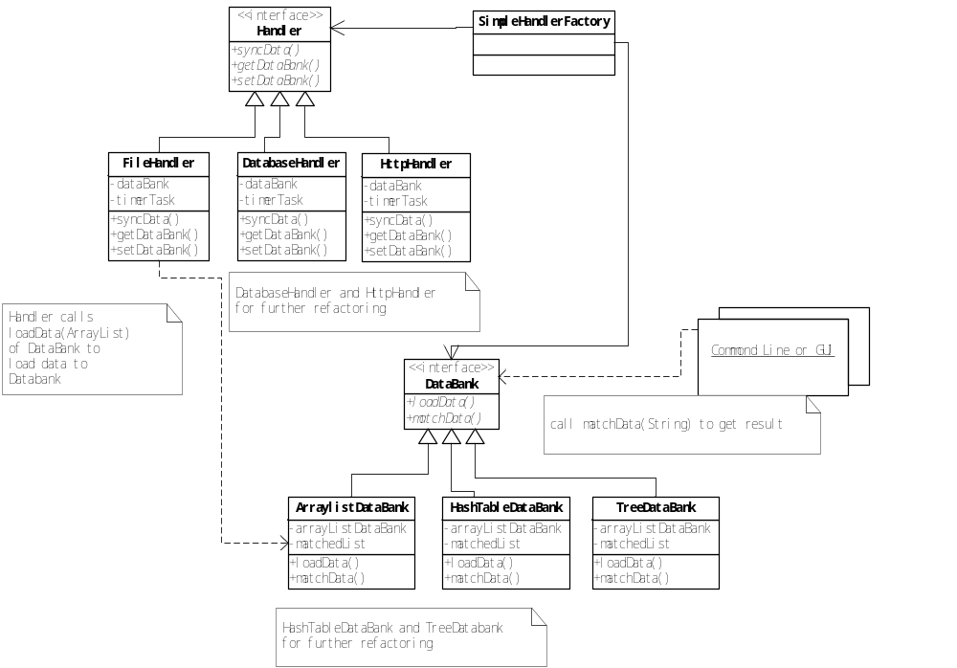

2. Package introduction
There are 3 packages in source folder, and 3 packages for JUnit test accordingly.

Package Name | Classes/Interface | Main Functions | Memo
com.breadtree.handler | Handler (interface) | Synchronize data interface  Get/set Databank instance | done
com.breadtree.handler | FileHandler | - timer task to read file every 5 seconds;  - read file and keep records in ArrayList, all words and characters are accepted here;  - call dataBank.loadData() to load data into databank, non english characters will be blocked out | done
com.breadtree.databank | DataBank (interface) | - load data into its own data structure;  - organize proper data structure for the purpose of efficiency and performance  - exposed matchData(String prefix) to users | done
com.breadtree.databank | TrieDataBank | As above  Use Trie as data bank | Done
Com.breadtree.handlerfactory | SimpleHandlerFactory | - create Handler instance;  - careate DataBank instance; | Done
 | DataBankType | enum | Done
Com.breadtree.util | HandlerType | enum | Done
com.breadtree.testmain | AutoCompleteTest | - while-loop in main to interact with user through command line  - initiate log4j | Done
Test packages |  | Unit tests for the implemented functions | Done (for key part only)

3. Configuration/log Files

File Name | Path | purpose
wordlist.txt | ./ | Configure the word list
log4j.properties | ./ | Log4j configuration file
matchup.log | ./log/ | Log for debugging and trouble shooting

4. Other Considerations
4.1. File Reading
If the file has no change, then no need to read the file or load data into databank again for the purpose of performance and safety.
The timer task could be switched off by setting taskStopSignal as true.

4.2. Synchronized Model
For the purpose of data integrity, when loading data, the databank data would be locked until the whole data was loaded successfully. The reverse is true as well.

4.3. Assumption / Size limitation
- All the words will be converted into lower case for storage and matchup.
- Only support English character only ([a-zA-Z]) in this version, all the unexpected words will be blocked out.
- If we need to support upper case storage or numeric (0-9), TrieDataBank needs to be refactored.
- Duplicated words will be counted in the Trie data bank, but show only one if there are duplicated words.
- If configuration file is missing or too big to be loaded, system will use the last latest information till the file is available.
- Length of input prefix should be shorter than 50, otherwise system will return null directly without matching databank.
- Size of wordlist.txt should be less than 10K.

5. Tools and Libraries

5.1. Development Environment
Eclipse under iMac (Mac OS)
Reasons:
powerful IDE platform;
unified interface for Java and Android development
5.2. Unit Test tool
JUnit4.0
Reason: mature and powerful unit test tool, easy to use
5.3. Log patch
Log4j
Reason: popular and powerful log tool

5.4. Diagram Tool
MS Visio
Reason: familiar with Visio

6. Tests in Extreme Conditions
6.1 Configuration Files
1) configuration file testword.txt is missing;
2) configuration file is replaced with a binary file bigger than 10K or smaller than 10K;
3) special character inside;
4) keep it running in 1 day.

6.2 Input Prefix
1) longer than 50 bytes;
2)special charactors
3) null or empty

6.3. Test across Platform
Mac OS
Windows

